**To restore an EBS volume from a snapshot using the console**

You can restore your EBS volume from a snapshot using the AWS Management Console as follows.

1. Open the Amazon EC2 console.
2. From the navigation bar, select the region that your snapshot is located in. 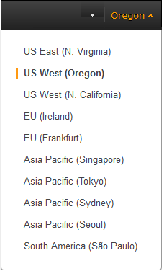
3. Click **Volumes** in the navigation pane.
4. Click **Create Volume**.
5. In the **Create Volume** dialog box, in the **Volume Type** list, select **General Purpose SSD**, **Provisioned IOPS SSD** or **Magnetic**. For more information,
6. In the **Snapshot** field, start typing the ID or description of the snapshot from which you are restoring the volume, and select it from the list of suggested options.
7. In the **Size** box, enter the size of the volume in GiB, or verify the that the default size of the snapshot is adequate.

If you specify both a volume size and a snapshot ID, the size must be equal to or greater than the snapshot size. When you select a volume type and a snapshot ID, minimum and maximum sizes for the volume are shown next to the **Size** list. Any AWS Marketplace product codes from the snapshot are propagated to the volume.

1. For Provisioned IOPS SSD volumes, in the **IOPS** box, enter the maximum number of input/output operations per second (IOPS) that the volume can support.
2. In the **Availability Zone** list, select the Availability Zone in which to create the volume. EBS volumes can only be attached to EC2 instances within the same Availability Zone.
3. Click **Yes, Create**.